The Governors of The Bellbird Primary School are the group of parents, staff and members of our community that decide on school policies, hold the Headteachers to account for the school’s performance, and ensure that the school’s budget and other resources are best used. We were rated as “Good” by OfSTED in July 2024. The Governors meet as a full group each half term, with some additional subcommittee meetings. Every year we provide a report to parents/carers to tell you about the things that Governors have been involved in during the year. This is our report covering the 2023/2024 academic year.

Dr

Tim Wreghitt, Chair of Governors
This has been another successful year for The Bellbird School, although we are extremely sad that at the end of the academic year, both of our Co-Headteachers have decided to move on to new positions in education in Cambridgeshire and we wish them well in their new positions. We are excited to welcome our new Co-Headteachers Matt Brough and Laura Fielding this term and James Puxley as our permanent new Headteacher in January 2025.
The Bellbird Primary School is governed by the Governing Body. It is the accountable body for the school and the sets the strategic direction together with the Headteacher and the leadership team. We are a small and committed group of people with a range of skills, backgrounds and experiences who are responsible for making decisions about how the work of the school is run. All governing bodies have certain obligations, legal duties, powers and responsibilities.
The Bellbird School Governing Body comprises:
■ 7 Community Governors
■ 6 Parent Governors
■ 1 Local authority Governor
■ Headteacher (ex-officio)
■ 1 Staff Governor
The Clerk to the Governors is Jane Boyce of Judicium Education.
New Governors/Resignations this academic year:
■ Steven Clarke (Parent Governor) resigned in February 2024
■ Nerea Ibarra (Community Governor) resigned in July 2023
■ Henry Weir (Community Governor) resigned in February 2024
■ Maja Rix (Staff Governor) resigned in October 2023
■ Peter Deane (Parent Governor) was elected in November 2023
■ Sam Goddard (Parent Governor) was elected in November 2023
■ Cynthia Okpokiri (Parent Governor) was elected in February 2024
■ Jacqui Watkins (Community Governor) was appointed in May 2024
■ Claire Abraham (Staff Governor) was elected in May 2024
■ Henry Weir (Community Governor) was re-appointed in July 2024
The Governing Body meets once each half term and the subcommittees usually meet once (or twice) each term.
There are several sub-committees:
■ Resources and Partnership committee (dealing with delegated finance, personnel, partnership and health and safety issues). Chaired by Phil O’Dell
■ Standards and Curriculum committee (reviews curriculum and children’s progress). Chaired by Emma Mba).
■ Health and Safety Group (reviews health and safety issues and reports to the Resources and Partnership committee). Chaired by Andy Irons.
■ Head Teacher performance Management committee (Chaired by John Rimell).
■ Salaries committee (Chaired by Phil O’Dell).
As you will see, our finances are in a good position and the school is almost full to capacity. Feedback from the Local Education Authority Advisors has been very supportive of the educational provision.
I would like to pay tribute to the hardworking staff and Governors for their hard work and dedication and thank our departing Governors – Steven Clarke, Nerea Ibarra and Maja Rix for their dedicated service to the school.
Finally, at the end of the summer term, we were inspected by Ofsted and I am delighted to say that they rated us as “Good”. This result is a tribute to the hard work and dedication of all staff, children, parents, and governors. I was incredibly impressed by the dedication of the Governors during the inspection – 9 attended an 8am meeting with inspectors. All in all, a very good year. Let’s keep it up!!

Governors
Tim Wreghitt | Chair, Local Authority Governor
Duncan Macfarlane | Vice Chair, Parent Governor
Becka Pentney,  Emma Clayton | Headteachers
Emma Mba | Parent Governor
Steven Clarke  (until February 2024) | Parent Governor
Cynthia Okpokiri (from February 2024) | Parent Governor
Maureen Tsentides | Parent Governor
Peter Deane (elected November 2023) | Parent Governor
Sam Goddard (from November 2023) | Parent Governor
Andy Irons | Community Governor
Katie Graham | Community Governor
Jacqui Watkins (from May 2024) | Community Governor
John Rimell | Community Governor
Phil O’Dell | Community Governor
Henry Weir (until February 2024). Re-joined in July 2024. | Community Governor
Maja Rix (until October 2023)  Claire Abraham (from May 2024) | Staff Governor
Jane Boyce (Judicium Education) | Clerk to Governors

Among our Board of Governors, we have various members who take a lead in key areas, including:
Diminishing the difference | Emma Mba and Tim Wreghitt
Writing | Tim Wreghitt and John Rimell
Our wider offer | Katie Graham
Middle Leadership | Duncan Macfarlane
Safeguarding | Maureen Tsentides, Henry Weir and Cynthia Okpokiri
Finance | Phil O’Dell
Special Educational Needs | Emma Mba
Property and Health and Safety | Andy Irons
Parent consultation | Duncan Macfarlane
Pupil Premium | Tim Wreghitt
Maths | Duncan Macfarlane
English/Literacy | Tim Wreghitt and John Rimell
FABS | Andy Irons

Headteachers’ report

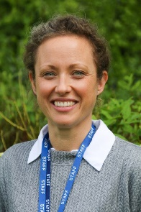
Mrs Rebecca Pentney and Mrs Emma Clayton
The 23/24 academic year has been a busy one at The Bellbird. We have been proud of the wonderful work our whole school community has committed to as we continue to ensure we provide the best possible education for all our children.
We started the academic year with a focus for our staff on ‘what makes good teaching’. Our training on this had a real evidence-based focus and staff were encouraged to engage and explore in what makes good teaching. Throughout the year we have asked staff to reflect and develop this thread with a particular focus on the learning intention for each lesson as well as they key teaching points and the adaptations individuals or groups may need to be successful. Staff have embraced this approach and monitoring throughout the year has shown how the work has been implemented and has impacted progress. Children have shown increased clarity on the purpose of their learning and the resources they have to help them.
We also began to look at our wider curriculum and beyond. Our curriculum focus helped us to review where there was strength, and we celebrated this. We also looked at areas where progression could be developed. This has resulted in exciting developments across the curriculum which will begin in September. This will build on our rich and broad curriculum offer, further strengthening our children’s acquisition and use of vocabulary. Beyond the formal curriculum offer this year has seen a focus on our wider offer. We have celebrated what we do to enrich and strengthen pupil experiences, both in events which support the curriculum such as trips and visits and with additional clubs which children can attend. A particular development this year was the development of lunchtime clubs run by our year 6’s. These have varied in themes and have encouraged our year 6 to develop as leaders in areas they have felt comfortable, they have been a real positive addition to our offer and a joy to watch our children supporting each other.
As the year came to an end, we were preparing for our new interim Headteacher, Mr Brough for the autumn term, followed by Mr Puxley beginning his substantive post in the spring term. These preparations have been thorough, and we have ensured all key documents are ready for a smooth transition and a continuation of our school’s development without disruption. The end of term saw a visit from Ofsted, we await the report. As always, we were proud of how our school community responded to the visit and the opportunity to share what they were proud of at The Bellbird.
We would like to take this opportunity to thank the Governing body for their positive support and challenge. Robust governance is essential to a school’s success. We leave knowing that The Bellbird is in safe hands and will continue to ‘soar to success’.

FABS
Andy Irons

FABS (Friends At Bellbird School) is the PTA at our school, and is run entirely by volunteer parents giving their time, with wonderful support from the school staff during our events. A huge thank you to all those who are involved. FABS exists for the dual purpose of running events for the Bellbird pupils and their families to enjoy, and to raise much needed money for the school. This year we have raised over £8,000 and have supported the school by providing cycle helmets for all new reception children, Christmas and Easter treats for all the children, buying books to top up the library, paying for swimming lessons, contributing towards the cost of the coach for the choir trip to the O2, buying re-usable costumes for the year 6 production and more.

Money Matters
Phil O’Dell
When setting the budget from 1st April 2024 the governors agreed to invest in three much needed posts; a pastoral welfare officer role, the continuation of the existing ‘booster’ teacher post, and the recruitment of an additional higher-level teaching assistant. In a full year, these posts will cost just under £100k, although the teaching assistant post will help to reduce our need for the use of agency staff when absences occur so will offset some our costs.
The governors were able to pay for these appointments partly through a slight increase in our government funding but also by using some of our quite substantial financial reserves. The reserves remain at an acceptable level, as endorsed by the county council’s financial advisor and governors will be working throughout the financial year to find economies that can replenish them and allow the school’s current activities to continue over the medium to long term. Our actions in this area will include continuing to compare our spending with other schools to try to identify better ways of spending our money, having a workshop to discuss realistic ideas to reduce our spending and/or get more value from what we do spend, and a small group of governors examining each of our budget items in detail to confirm that it is needed and well spent.
The school now spends approximately £2.4m per annum, with most of that coming from the government and the county council on a formula basis though we also receive money from letting our premises out of hours and benefit from the fundraising of our local community via our active FABS group to whom we are very grateful.
In addition to setting the budget for the year ahead, governors also monitor the budget in-year and analyse the year-end spending compared to budget. For the year ending 31st March 2024 the school had a net underspend of approximately £40k on a budget of £2.3m for that year, which was a favourable variance of 1.7%, indicating good budgetary control.
“…the main financial challenge facing the school now concerns our capital monies…”
The main financial challenge facing the school now concerns our capital monies, where our building has several urgent needs and some of our IT equipment, such as laptops for the children and staff need replacement. The governors will be addressing these issues in the coming months. We also await news of the first funding settlement for schools to be announced by the new Government.
As always, the governors thank our staff for their work on our finances.

Safeguarding
Maureen Tsentides, Henry Weir and Cynthia Okpokiri
Keeping children safe is the responsibility of every adult within the school. However, ensuring that all staff and suppliers with access to children are properly vetted and deemed safe to be around children is part of the roles of the school Governors. In the last school year, the nominated link Governors responsible for safeguarding undertook required visits to the school to monitor and review practices and policies meant to keep children safe in the school. During these visits, the designated safeguarding Governors reviewed the Single Central Record (SCR), which is the document where the DBS checks and work clearance records of every staff or personnel in the school are kept. The Governors confirmed that the SCR is appropriately completed and updated, and that the office staff member who maintains the record indeed follows all available guidance in undertaking the task.
The Governors attend necessary training regarding safeguarding and check that staff and other relevant personnel are up to date with similar required training. Staff and personnel have the various means, including whistleblowing, to raise concerns about the well-being of children and staff. Parents and guardians can also raise concerns with the school or Governors and do have access to safeguarding information including advice and parenting training options in the parents’ tab of the school’s website.
The school and Governors keep a clear channel of communication with the Local Authority to ensure that new policy developments, including national updates, are received in a timely fashion and applied with due diligence, to ensure that all pupils and staff stay safe within the school.

FEEDBACK
Duncan Macfarlane
This year, we used the Ofsted Parent View survey for parent feedback. There were 140 respondents throughout the 23/24 academic year, which continues the pattern of increasing engagement.

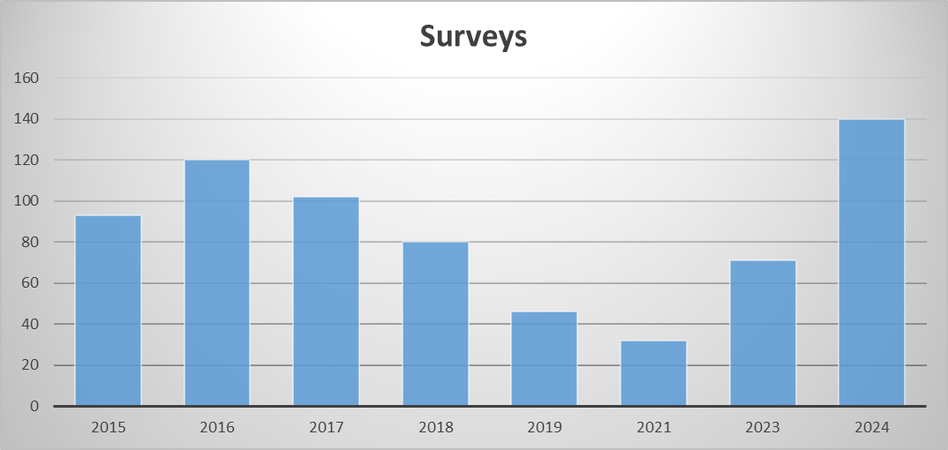
This is great news, as with more engagement we get a better picture of parent/carers’ views and can use that information to support decision making.
Overall, >87% of the respondents agreed with the statements, with particularly high scores for "The school makes me aware of what my child will learn during the year"; "My child feels safe at school"; "I would recommend the school to another parent" and "There is a good range of subjects available to my child at this school".

Sharing
To facilitate oversight of the various curricula areas, Governors pair with the Teacher Curricula Leads. We are always particularly keen to discuss resource matters with the teachers and how any additional funds we might manage to afford can be put to best use to help the children.

THANK YOU
The Governors would like to thank all the school staff who have worked tirelessly over the last year to make The Bellbird School an excellent successful environment for learning. Their achievements are plain for all to see, and they and our pupils are a credit to the school. Thank you also to our wonderful parents and carers for your help and support.

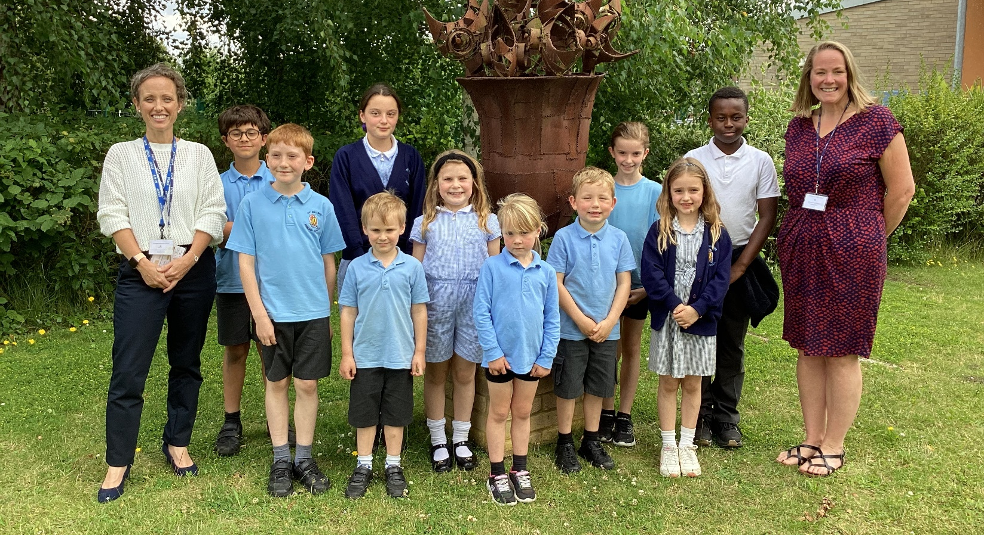


How to contact us
Governors are contactable via the School Office and website. Any matters regarding day-to-day issues, including complaints, should be discussed with either your child’s Class Teacher or the Headteachers.

